

E

-

assessment

-

Solution to hire talent

Project Report



I

nternet & Web System

Chinmay Matakari

(

02007302

)

Team

Member:

Utpal

P

atel

Eswarsanthoshkumar_Mamillapalli@student.uml.edu

Harshavardhan_mandhadi@student.uml.edu

Sravani_Dhanekula@student.uml.edu

(

0200

6609

)

**Table of Content**

|  |  |  |
| --- | --- | --- |
| **Sr. No** | **Index** | **Page** |
| **Chapter 1** | **Abstract** | 02 |
| **Chapter 2** | **Work** |  |
| 2.1 | Project work | 03 |
| 2.2 | Project workflow | 04 |
| 2.3 | Division of work | 05 |
| 2.4 | Technologies | 06 |
| **Chapter 3** | **Installation Process** |  |
| 3.1 | Build/Installation/launch Instruction | 07 |
| 3.2 | Use of Software | 08 |
| **Chapter 4** | **Limitations** | 09 |
|  |  |  |
| **Chapter 5** | **Future Work** | 09 |
| **Chapter 6** | **References** | 10 |

# CHAPTER-1

**Abstract:**

The "ADVENTURE" web application is a modern and user-friendly platform for people who love outdoor activities and adventures. It's been carefully built with HTML, CSS, and JavaScript to look good and work well on different devices. The app is easy to use, with a clear navigation bar that lets users quickly find sections like Home, Activities, Explore, Tours, and more. It has a great-looking header with a slogan that grabs your attention. One of the key parts of the app is the events section, which shows lots of different outdoor activities, each with its description and more information. This section encourages users to check out all sorts of adventures. Besides this, the app has special sections for exploring different places and joining tours, all with attractive pictures and full details. These sections are made to get users excited about discovering new places and going on tours. There’s also an "About Us" section that tells you about the company and its values, helping to build trust. For user support, there's a "Contact Us" section with a form and other ways to get in touch like email and phone. The app also connects to social media, showing it’s up-to-date and part of a larger community of adventure lovers. It's a complete guide that gives detailed information about various travel spots like peaceful beaches, beautiful trails, and interesting places to see. The website is not just about giving information; it's designed to make the user's experience better. It lets travelers set up their accounts or login to them. This feature makes the experience more personal and customized, helping users plan their travels in a way that fits their likes and interests. Overall, "ADVENTURE" is more than just an app; it's a lively and engaging place for adventure enthusiasts to find information and get involved in activities.

**Problem Statement:**

The main purpose of developing the "ADVENTURE" website is to make sure it meets the needs of people who love outdoor activities. It should work well on computers and phones and always have the latest and most interesting information about outdoor adventures like going to beaches or hiking trails. Also, the website wants to give each person a personal experience by letting them create accounts and choose what they like. It's not just about giving information; it wants to be a helpful and fun place for adventure lovers to plan their trips and connect with others who love outdoor activities too. So, the purpose of this website is to be a one-stop destination for adventure enthusiasts to find, plan, and enjoy their outdoor adventures while being part of a community of like-minded individuals.

# CHAPTER-2: WORK

**2.1 Project work**

Our project is divided into two sections: recruiter and applicant. The recruiter will sign up for the web app and be prompted to provide information about the firm and other details. After logging into the system, the recruiter will be forwarded to the homepage, where he or she may develop new assessments. This form primarily asks for the assessment's title and job position, after which the recruiter can add the candidate's name and email- mail address of them he or she would like to evaluate. The recruiter will next create the questions for the created test, which will be separated among multiple choice questions, coding questions, essay writing questions, video questions, and multiple select questions.

**2.2 Workflow:**

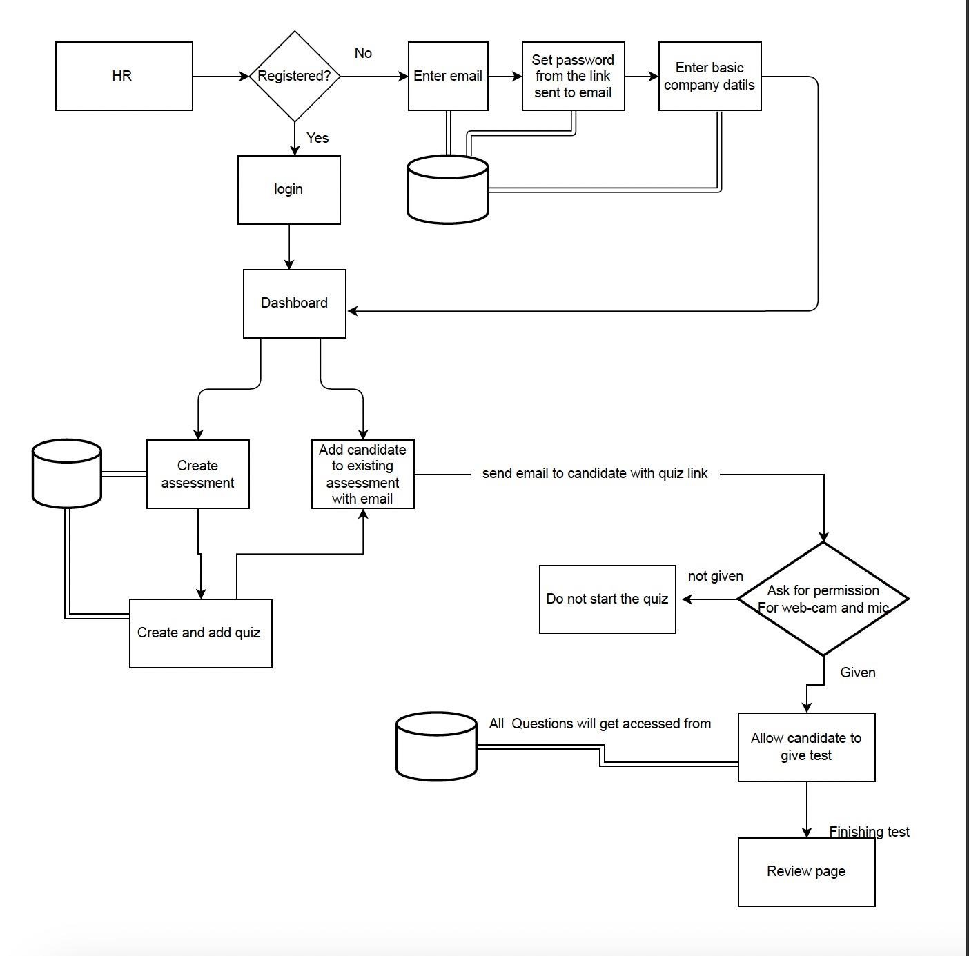

**2.3 Division of labor among team members**

I have taken care of all the front end i.e., preparing pages in React JS. Resolved issues with rendering elements and worked on the code editor. As ttechnologies used the in the project are totally new to me, I studied react first via YouTube and worked on the project. In this project, I learned how to send the payload to API. I have also created a few sample APIs in python to see whether the pages designed by me working properly or not. In this project, I was responsible for designing and fetching the values of questions posted in the database. Also, I have used Cloudinary and taken images every after 10 sec of live streaming and stored those images in Cloudinary.In addition to this, I have integrated the backend and frontend part I faced a lot of issues while integrating both sides. Issues like ERROR CODE 404,401,500.

My Project partner took care of all the back-end parts. Creating APIs, sending emails, and handling tokens throughout the session.

**2.4 Technologies:**

• In this project, we used

1. React is a front-end JavaScript library. React is capable of making API calls (sending the request to the backend), which deal with the data. Also react is used by most companies now nowadays Instagram, Airbnb, discord, etc. so to learn and get hands-on experience during the course we decided to use React.

1. We decided to use the python Flask framework at the backend to perform the get, put, post, and delete operations on data. We decided to use python because python is getting more popular day by day also there are many packages that are directly available in python such as m2Crypto.

We used ‘Sha256’ Encryption to encrypt passwords and store them in a database. Additionally, having hands-on experience in python will give us chance to learn ML, Data Analytics, and AI in the future. Some companies using python are google, Facebook, etc.

1. We decided to use MySql as a database because it is easy to use and highly efficient and secure. We can easily write and understand SQL queries.

# CHAPTER 3: INSTALLATION PROCESS

**3.1 Build/Installation/launch Instruction** Installation Process:

o To clone the project from git use git clone“ [https://github.com/chinmayn1/comp5130f2022.git”](https://github.com/chinmayn1/comp5130f2022.git)

After cloning navigate to IWS1- project final directory o For react

1. For React modules there are two folders (react-backend and react front-end) we need to install nodes to run them.
2. You can check node is installed or not by ‘node-version’
3. If it’s installed, then open projects and type the command ‘npm update
4. After that use ‘npm start’.
5. If the node is installed, then install the node from <https://nodejs.org/en/download/>6. After successful installation of the node perform steps 2 to 4

o For python

1. For python we need to check whether python is installed or not by command

‘python –version’

1. If it is installed the type command ‘pip install -r requirements.txt’.
2. Type the command ‘venv\scripts\activate’.
3. After that type of ‘flask run’.
4. If python is not installed, then install it from <https://www.python.org/downloads/>6. After installation of python perform steps 2 to 4

## 3.2 Use of Software

In this project, there are total 2 Module

1. Recruiter
2. Candidate

o Recruiter: -

1. The recruiter will first sign up for the web application, after which he or she will receive an email asking them to verify their email address and create a password. Upon login, the recruiter will get redirected to the dashboard which will provide the history of past assessments, if any.
2. A recruiter may build a new exam on the dashboard. In the assessment, the recruiter can design a quiz using a variety of tools, including coding, MCQ, MSQ, video recording, essay writing, etc.

1. After creating an assessment with questions and dedicated time, the recruiter has the option to add a candidate with a first name, last name, and email address. Upon successful addition email with a link to the assessment will be sent to the email entered while inviting the candidate. A recruiter can delete the candidate later.

o Candidate: -

1. The recruiter's email with the web link is the candidate's entrance point. When the candidate clicks on the link, he will get redirected to the assessment questions.

1. Before starting to attempt the quiz web page requests the candidate's image and must be granted access to the camera.

1. The front end will use the camera to capture the screen, and the candidate must submit their answers within the time limit set by the recruiter for each question.

1. While taking the quiz, we ask that the candidate keep their webcam turned on so that we can take screenshots and not have to upload the entire streaming video.

## CHAPTER-4: Limitations

My project has the following limitations (list below)

1. Candidate and HR/ Recruiter cannot see the result of the exam.
2. HR/ Recruiter cannot edit and delete the Assessment. They always need to create new always.
3. HR can not backtrace while creating an assessment.
4. If the candidate removes access given to the webcam and mic in between then also he can submit the test.

## CHAPTER-5: Future Work

In this project, we have some limitations we can work on those in the future, and also we can use bootstrap technology to make websites responsible for devices of different sizes.

### CHAPTER-6: References

1. [**https://bootcamp.uxdesign.cc/7-benefits-of-using-mysql-in-your-business-e587e326144f**](https://bootcamp.uxdesign.cc/7-benefits-of-using-mysql-in-your-business-e587e326144f)
2. [**https://reactjs.org/docs/getting-started.html**](https://reactjs.org/docs/getting-started.html)
3. [**https://stackoverflow.com/**](https://stackoverflow.com/)
4. [**https://github.com/manuarora700/react-code-editor**](https://github.com/manuarora700/react-code-editor)
5. [**https://www.npmjs.com/package/react-simple-code-editor**](https://www.npmjs.com/package/react-simple-code-editor)
6. [**https://www.w3schools.com/**](https://www.w3schools.com/)
7. [**https://www.javatpoint.com/reactjs-tutorial**](https://www.javatpoint.com/reactjs-tutorial)
8. [**https://www.youtube.com/playlist?list=PL7yh-TELLS1E6dNCzfQl-NG-KJP3C-4mc**](https://www.youtube.com/playlist?list=PL7yh-TELLS1E6dNCzfQl-NG-KJP3C-4mc)
9. [**https://www.youtube.com/playlist?list=PL7yh-TELLS1F3KytMVZRFO-xIo_S2_Jg1**](https://www.youtube.com/playlist?list=PL7yh-TELLS1F3KytMVZRFO-xIo_S2_Jg1)
10. [**https://www.youtube.com/playlist?list=PL7yh-TELLS1FuqLSjl5bgiQIEH25VEmIc**](https://www.youtube.com/playlist?list=PL7yh-TELLS1FuqLSjl5bgiQIEH25VEmIc)
11. [**https://www.youtube.com/playlist?list=PL7yh-TELLS1GNyuvPsFEqb7JVMEUTtuau**](https://www.youtube.com/playlist?list=PL7yh-TELLS1GNyuvPsFEqb7JVMEUTtuau)
12. [**https://www.youtube.com/watch?v=w7ejDZ8SWv8**](https://www.youtube.com/watch?v=w7ejDZ8SWv8)
13. **https://www.youtube.com/watch?v=b9eMGE7QtTk**